

**TEST PLAN**

**Date | Location:** 26 March 2021 | Eindhoven

**Tutor:** Brice Guayrin

**Members**

Yordan Ivanov

Merva Khan

Radoslav Mechkov

Contents

**Use Case 1 12**

**Use cases 12**

**Use Case 2 13**

**Use Case 3 13**

**Use Case 4: 14**

**Use Case 5: 14**

**Use Case 6 15**

**Use Case 7 15**

**Use Case 8 16**

**Use Case 9 16**

**Use Case 10 17**

**Use Case 11 17**

**Use Case 12 18**

**Use Case 13 18**

**Use Case 14 19**

**Use Case 15 19**

**Use Case 16 20**

**Use Case 17 20**

**Use Case 18 21**

**Use Case 19 21**

**Use Case 20 22**

**Use Case 21 22**

**Use Case 22 23**

**Test cases: 23**

**TC1 24**

**TC2 24**

**TC3 24**

**TC4 24**

**TC5 24**

**TC6 24**

**TC7 24**

**TC8 24**

**TC9 24**

**Tc10 25**

**TC11 25**

**TC12 25**

**TC13 25**

**TC14 25**

**TC15 25**

**TC16 25**

**TC17 25**

**TC18 25**

**TC19 25**

**TC20 26**

**TC21 26**

**TC22 26**

**TC23 26**

**TC24 26**

**TC25 26**

**TC25 26**

|  |  |
| --- | --- |
| **Use Case 1** | **Login** |
| **Summary:** | **In order to get personalized or restricted information, a user must login so that the system can determine his access level.** |
| **Basic Flow:** | 1. **The use case starts when a user indicates that he wants to login.** 2. **The system requests the username and password.** 3. **The user enters his username and password.** 4. **The system verifies the username and password against all registered users.** 5. **The system starts a login session and displays a welcome message based on the user's preferences.** |
| **Alternative Flows:** | **If username is invalid, the use case goes back to point 2 of basic flow.**  **If the password is invalid the system requests that the user re-enter the password.** |
| **Preconditions** | **The user is registered.** |
| **Post conditions** | **The user get access to his account depending on his access level.** |

## Use cases

|  |  |
| --- | --- |
| **Use Case 2** | **Add employee** |
| **Summary:** | **The administrator adds a new employee.** |
| **Basic Flow:** | 1. **The use case starts when an administrator wants to input information.** 2. **The system requests to add the new employee** 3. **The admin enters the information.** 4. **The system saves the information and stores it.** |
| **Alternative Flows:** | **none** |
| **Preconditions:** | **Already added employee** |
| **Post conditions:** | **The new employee is registered in the system** |

|  |  |
| --- | --- |
| **Use Case 3** | **Remove employee** |
| **Summary:** | **The administrator removes an existing employee from the system** |
| **Basic Flow:** | 1. **The use case starts when an administrator wants to remove an employee** 2. **The system removes the employee** 3. **The system updates the changes.** |
| **Alternative Flows:** | **None** |
| **Preconditions:** | **none** |
| **Post conditions:** | **The employee is removed from the system** |

|  |  |
| --- | --- |
| **Use Case 4:** | **Edit employee** |
| **Summary:** | **The administrator edit an existing employee in the system** |
| **Basic Flow:** | 1. **The use case starts when an administrator wants to edit an employee** 2. **The admin enters the information** 3. **The system edits the employee** 4. **The system updates the changes.** |
| **Alternative Flows:** | **None** |
| **Preconditions:** | **none** |
| **Post conditions:** | **The employee is edited in the system** |

|  |  |
| --- | --- |
| **Use Case 5:** | **Create schedule** |
| **Summary:** | **The administrator creates a schedule for a new date** |
| **Basic Flow:** | **The use case starts when an administrator wants to create schedule.****The system requests ID, date , job type and number of employees to work.****The administrators choose that information.****The system saves the information and displays it in the schedule.** |
| **Alternative Flows:** | **An administrator could’ve already created a schedule for the same day.** |
| **Preconditions:** | **Already created a schedule.** |
| **Post conditions:** | **The employee is scheduled.** |

|  |  |
| --- | --- |
| **Use Case 6** | **Assign shift to employee** |
| **Summary:** | **The administrator adds employee to a specific day.** |
| **Basic Flow:** | 1. **The use case starts when an administrator wants to schedule an employee.** 2. **The system requests the employee and the day.** 3. **The administrator clicks on the row of the wanted day.** 4. **The combo box fills itself.** 5. **The administrators choose the employee and ID of the shift.** 6. **The system saves the information and displays it in the shifts.** |
| **Alternative Flows:** | **An administrator could’ve already scheduled too many employees to the same day.**  **An employee is already added to that day.** |
| **Preconditions:** | **Already scheduled employee.** |
| **Post conditions:** | **The employee is scheduled.** |

|  |  |
| --- | --- |
| **Use Case 7** | **Request stock** |
| **Summary:** | **Sales representative can request stock from the depot.** |
| **Basic Flow:** | 1. **The use case starts when the user wants to request a stock for use.** 2. **The system requests information about the stock.** 3. **The request is sent and the status is showed in the data grid.** |
| **Alternative Flows:** | **None** |
| **Preconditions:** | **None** |
| **Post conditions:** | **None** |

|  |  |
| --- | --- |
| **Use Case 8** | **Edit employee’s own information** |
| **Summary:** | **The employee can edit his own information in the system** |
| **Basic Flow:** | 1. **The use case starts when the user wants to edit an employee** 2. **The user changes the information** 3. **The system edits the employee** 4. **The system updates the changes.** |
| **Alternative Flows:** | **None** |
| **Preconditions:** | **none** |
| **Post conditions:** | **The user is edited in the system** |

|  |  |
| --- | --- |
| **Use Case 9** | **Add stock** |
| **Summary:** | **Depot worker can add stock.** |
| **Basic Flow:** | 1. **The use case starts when the employee wants to add stock.** 2. **The system requests information about the stock.** 3. **The system updates the changes.** |
| **Alternative Flows:** | **none** |
| **Preconditions:** | **none** |
| **Postconditions:** | **The stock is updated in the system** |

|  |  |
| --- | --- |
| **Use Case 10** | **Proceed Request** |
| **Summary:** | **Depot worker can proceed the request.** |
| **Basic Flow:** | 1. **The use case starts when the employee wants to proceed the request.** 2. **The system requests information about the request.** 3. **The administrators add the new stock.** |
| **Alternative Flows:** | **If the quantity of requested product is not enough, employee have to first add stock to proceed the request** |
| **Preconditions:** | **none** |
| **Postconditions:** | **Request is proceed successfully** |

|  |  |
| --- | --- |
| **Use Case 11** | **Edit employee’s own information** |
| **Summary:** | **The employee can edit his own information in the system** |
| **Basic Flow:** | 1. **The use case starts when the user wants to edit an employee** 2. **The user changes the information** 3. **The system edits the employee** 4. **The system updates the changes.** |
| **Alternative Flows:** | **None** |
| **Preconditions:** | **none** |
| **Postconditions:** | **The user is edited in the system** |

|  |  |
| --- | --- |
| **Use Case 12** | **Add new product type** |
| **Summary:** | **Depot worker can add new product** |
| **Basic Flow:** | 1. **The use case starts when the depot worker wants to add a new product type.** 2. **The system requests information about the product type.** 3. **The depot worker add the new product type.** 4. **Product type will also added in the combo boxes** |
| **Alternative Flows:** | **none** |
| **Preconditions:** | **none** |
| **Postconditions:** | **New product type is added in the system** |

|  |  |
| --- | --- |
| **Use Case 13** | **Edit product type** |
| **Summary:** | **Depot worker can edit product type** |
| **Basic Flow:** | 1. **The use case starts when the depot worker wants to edit product type.** 2. **The system requests information about the product type.** 3. **The depot worker edits the product type.** |
| **Alternative Flows:** | **none** |
| **Preconditions:** | **none** |
| **Postconditions:** | **Product type is updated in the system** |

|  |  |
| --- | --- |
| **Use Case 14** | **Remove product type** |
| **Summary:** | **Depot worker can remove product type** |
| **Basic Flow:** | 1. **The use case starts when the depot worker wants to remove product type.** 2. **The system requests information about the product type.** 3. **The depot worker removes the product type.** 4. **Product type will also remove from combo boxes** |
| **Alternative Flows:** | **none** |
| **Preconditions:** | **none** |
| **Postconditions:** | **Product type is removed from the system** |

|  |  |
| --- | --- |
| **Use Case 15** | **Add product** |
| **Summary:** | **Depot worker can add product** |
| **Basic Flow:** | 1. **The use case starts when the depot worker wants to add product.** 2. **The system requests information about the product.** 3. **The depot worker add the product.** |
| **Alternative Flows:** | **none** |
| **Preconditions:** | **none** |
| **Postconditions:** | **Product is added in the system** |

|  |  |
| --- | --- |
| **Use Case 16** | **Edit product** |
| **Summary:** | **Depot worker can edit product** |
| **Basic Flow:** | 1. **The use case starts when the depot worker wants to edit product.** 2. **The system requests information about the product.** 3. **The Depot worker changes the info.** 4. **The depot worker edit the product.** |
| **Alternative Flows:** | **none** |
| **Preconditions:** | **none** |
| **Postconditions:** | **Product is updated in the system** |

|  |  |
| --- | --- |
| **Use Case 17** | **Remove product** |
| **Summary:** | **Depot worker can remove product** |
| **Basic Flow:** | 1. **The use case starts when the depot worker wants to remove product.** 2. **The system requests information about the product.** 3. **The depot worker removes the product.** |
| **Alternative Flows:** | **none** |
| **Preconditions:** | **none** |
| **Postconditions:** | **Product is updated in the system** |

|  |  |
| --- | --- |
| **Use Case 18** | **View Employees by Age** |
| **Summary:** | **Manager can view employees by age** |
| **Basic Flow:** | 1. **The use case starts when the manager wants to view employees by age** 2. **Select by age, select department click show** 3. **Following employees will show in grid.** |
| **Alternative Flows:** | **none** |
| **Preconditions:** | **none** |
| **Postconditions:** |  |

|  |  |
| --- | --- |
| **Use Case 19** | **View Employees By gender** |
| **Summary:** | **Manager can view employees by gender** |
| **Basic Flow:** | 1. **The use case starts when the manager wants to view employees by gender** 2. **Select by gender, select any gender select department click show** 3. **Following employees will show in grid .** |
| **Alternative Flows:** | **none** |
| **Preconditions:** | **none** |
| **Postconditions:** |  |

|  |  |
| --- | --- |
| **Use Case 20** | **View all products** |
| **Summary:** | **Manager can view all the stock** |
| **Basic Flow:** | 1. **The use case starts when the manager wants to view all products** 2. **Click view all products** 3. **All products will show in grid .** |
| **Alternative Flows:** | **none** |
| **Preconditions:** | **none** |
| **Postconditions:** |  |

|  |  |
| --- | --- |
| **Use Case 21** | **View most sold product** |
| **Summary:** | **Manager can view most sold product** |
| **Basic Flow:** | 1. **The use case starts when the manager wants to view most sold product** 2. **Click view all products** 3. **Most sold products will show in grid .** |
| **Alternative Flows:** | **none** |
| **Preconditions:** | **none** |
| **Postconditions:** |  |

|  |  |
| --- | --- |
| **Use Case 22** | **View all shifts** |
| **Summary:** | **Manager can view all shifts** |
| **Basic Flow:** | 1. **The use case starts when the manager wants to view shifts** 2. **All shifts will be shown in grid** |
| **Alternative Flows:** | **none** |
| **Preconditions:** | **none** |
| **Postconditions:** |  |

## Test cases:

|  |  |  |  |  |  |  |
| --- | --- | --- | --- | --- | --- | --- |
| ID | UC | Name | Pre-condition | Test data | Excepted result | Peers feedback |
| TC1 | UC1 | Login as administrator | Application is running | Login username: JakeCollins  Login password: Password | User is successfully logged in and redirected to the page for administrator. | Login successful and redirected correctly. |
| TC2 | UC1 | Login as sales representative | Application is running | Login username: TedRashoford  Login password: Password | User is successfully logged in and redirected to the page for sales. | Login successful and redirected correctly. |
| TC3 | UC1 | Login as manager | Application is running | Login username: MattDamon  Login password:  Password | User is successfully logged in and redirected to the page for manager. | Login successful and redirected correctly. |
| TC4 | UC1 | Login as depot worker | Application is running | Login username: SaraConner  Login password:  Password | User is successfully logged in and redirected to the page for depot. | Login successful and redirected correctly. |
| TC5 | UC2 | Adding a new employee | User is administrator | None of the text boxes are null and whether is need a integer to be an integer. | After clicking the Add button the system will add the employee and show his information in the data grid. | If everything is filled in correctly, it succeeds in adding an employee.  Possible errors:  Duplicate primary key.  Valid phone numbers (with country specified) are larger than the int32 limit and thus invalid.  Duplicate username. |
| TC6 | UC3 | Removing an employee | User is administrator | The textbox with id is equal to the id of the wanted employee. | After clicking the Remove button the system will remove the employee and his information. | Deleted successfully.  Possible errors:  If user does not exist it will still report “Deleted successfully” even though the user does not exist.  If I delete an employee that doesn’t have the highest id, the id of the employee that is after it doesn’t go a step down.[1] |
| TC7 | UC4 | Editing an employee | User is administrator | The textbox with id is equal to the id of the wanted employee and none of the text boxes are null and whether is need an integer to be an integer. | After clicking the Edit button the system will update the employee and show his information in the data grid. | Edits successfully and the edited data is displayed within the grid.  Possible errors:  Duplicate username. |
| TC8 | UC5 | Create a schedule | User is administrator | The user enters ID of the schedule, date, number of people and type of job. | After clicking Create schedule, a schedule is created and shown in the data grid. | *Id of the schedule?*  Possible errors:  Duplicate primary key |
| TC9 | UC6 | Assign shift | User is administrator | The user clicks the row of the wanted date from the data grid, then enters ID of the schedule and name of the employee from the combo box. | After clicking Assign employee, a shift is created and shown in the data grid. | Adds successfully  Possible errors:  Duplicate primary key[2] |
| Tc10 | UC7 | Request stock | User is sales representative | The user enters the wanted information. | The user clicks the Request button and the request is shown on the data grid and sent to the Depot department. | Request is sent correctly if all the information is valid.  Possible errors:  Duplicate primary key[3] |
| TC11 | UC8 | Edit employee’s own information | User is sales representative | The user changes the information in the textboxes . | After clicking the Edit button the system will update the employee. | Information is edited successfully  Possible errors:  Duplicated username. |
| TC12 | UC9 | Add stock | User is Depot worker | User selects any row. Product ID will appear in textbox user can add quantity and also the price if the added product is new. | User Clicks “Apply” system will add the applied changes | Stock is successfully added.  Possible errors:  An error message pops up saying: “Please make sure to select any product first!” while already having a product selected. This happens when I enter a non-numeric character into one of the text boxes.[4] |
| TC13 | UC9 | Search Product Type | User is Depot worker | User will select any product type. | User will click “Search” Product of that type will show in grid | Search is performed correctly. All the [type] products are shown.  Possible errors:  !! Program crash when entering any non-existing product type. Search query: “Search”[5] |
| TC14 | UC10 | Request Proceed | User is Depot worker | User selects row request data will appear in corresponding textboxes | User will click “Request Proceed” if the requested quantity of the product is less in stock error message will appear user has to first add quantity of that product. Otherwise request will sent. | Possible errors:  !! Program crash after selecting a request that has been marked “Completed” in the same session.[6]  The error message as described pops up when the status is already “Completed” |
| TC15 | UC  11 | Edit employee’s own information | User is Depot worker | The user changes the information in the textboxes . | After clicking the Edit button the system will update the employee. | Information is edited successfully  Possible errors:  Duplicated username. |
| TC16 | UC  12 | Add new product type | User is Depot worker | User will enter new product type | User will click “Add” new type will be added and will also added in comboboxes | Added successfully |
| TC17 | UC  13 | Edit product type | User is Depot worker | User will click any product type data will show in textbox | User will click “Edit” product type will be edited and will also edited in comboboxes | Product type is successfully edited and it will be edited in the combo boxes. |
| TC18 | UC  14 | Remove product type | User is Depot worker | User will click any product type data will show in textbox | User will click “Remove” product type will be removed and will also removed from combo boxes | Product type is successfully deleted and it will be edited in the combo boxes. |
| TC19 | UC  15 | Add product | User is Depot worker | User will select any product type give it a name | User will click “Add” product will be added and will also added in manage stock grid | Product is successfully added. |
| TC20 | UC  16 | Edit product | User is Depot worker | User will select any product data will appear in corresponding textboxes  User will change data | User will click “Edit” product will be edited . | Product will be edited successfully. |
| TC21 | UC  17 | Remove product | User is Depot worker | User will click on any product all data will show in corresponding textboxes | User will click “Remove” product will be removed . | Product will be removed successfully. |
| TC22 | UC  18 | View employees by age | User is a Manager | User will select role and will select by age. User will enter starting and ending ages | User will click “Show” employees between those ages and having the selected role will show. | Search query: Starting age: 0  Ending age: 99  Results: 3 results show up correctly and they are within the age range of 0-99. |
| TC23 | UC  19 | View employees by gender | User is a Manager | User will select role and will select by gender and will choose any gender. | User will click “Show” employees with that gender and having the selected role will show. | Possible errors:  There are no results for both male and female in the administrator role, even though there are administrators.[7] |
| TC24 | UC  20 | View all products | User is a Manager |  | User will click “View all products” all products will | All products show up correctly and are listed. |
| TC25 | UC  21 | View most sold products | User is a Manager |  | User will click “Most sold products” most sold products will be shown | 3 products are listed.[8] |
| TC25 | UC  22 | View all shifts |  |  | All shifts will be shown | All shifts are displayed properly. |

1. 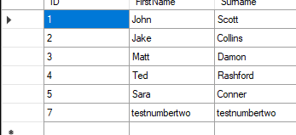
2. 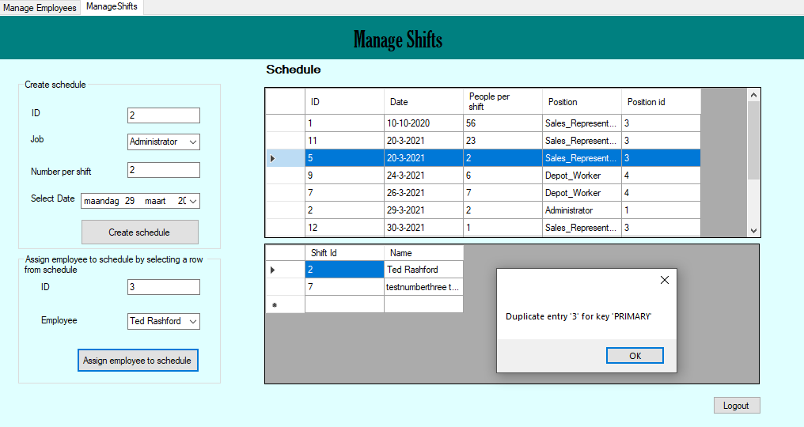
3. 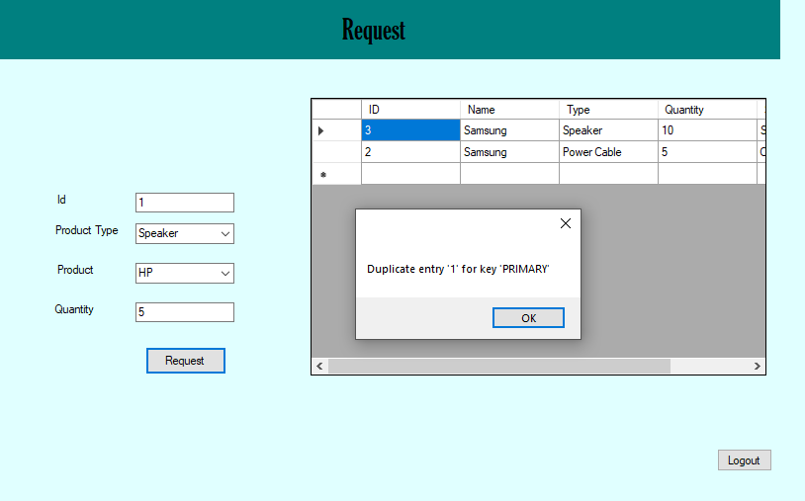
4. 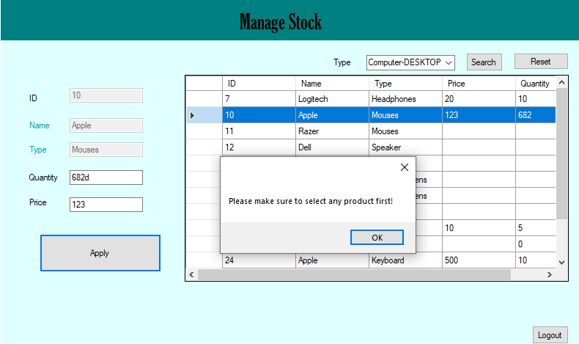
5. 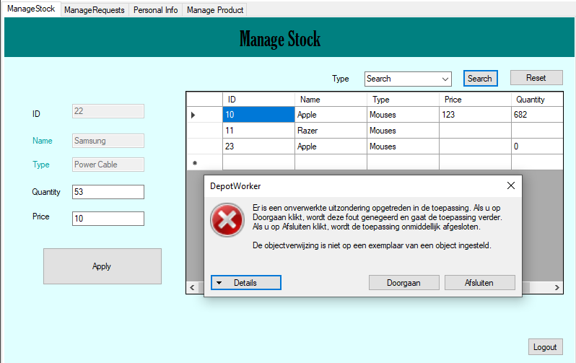

   Error: <https://pastebin.com/e97tqHth>
6. 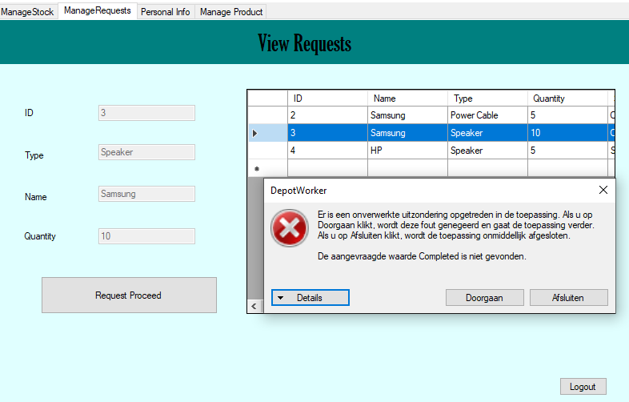

   Error: <https://pastebin.com/fRPscpLy>
7. 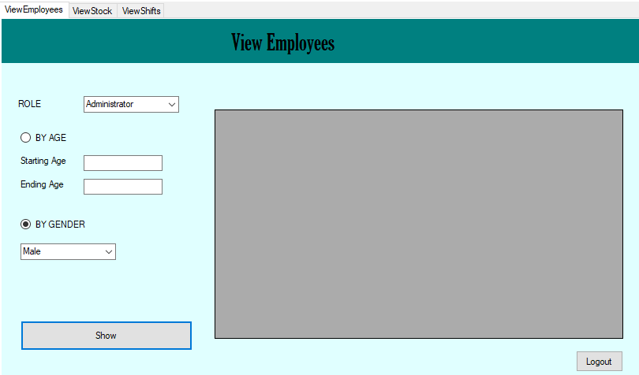

   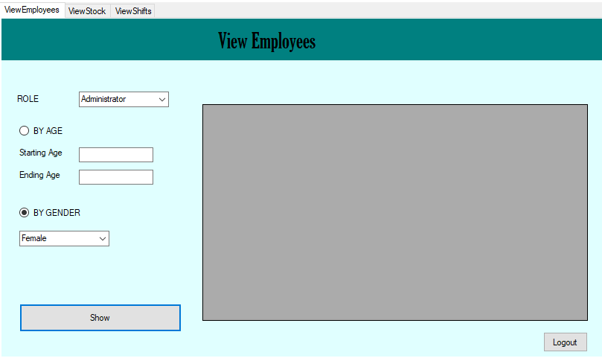
8. Results: